Task 9

1. Chat GPT

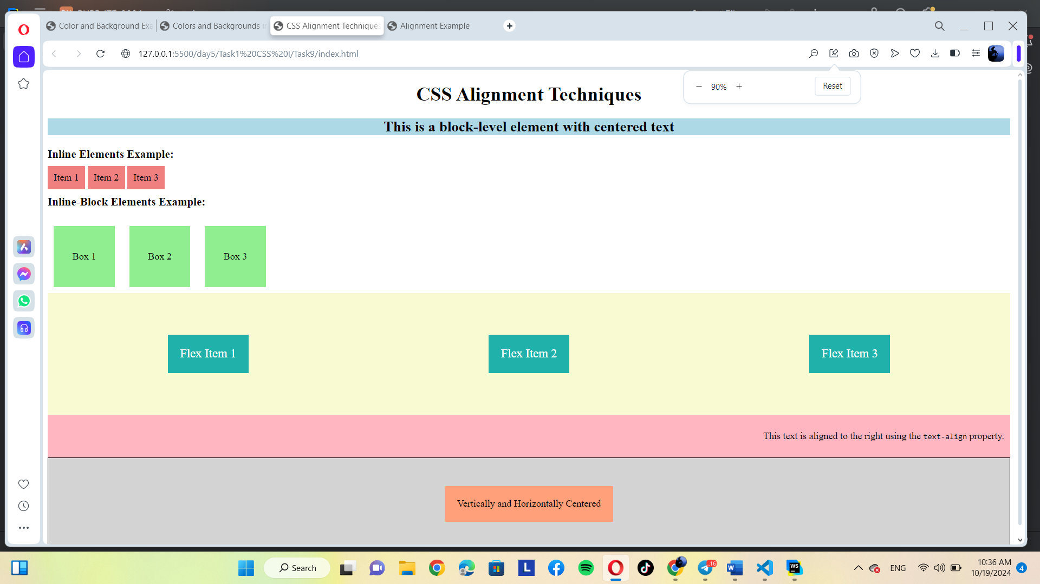

2. Gemini

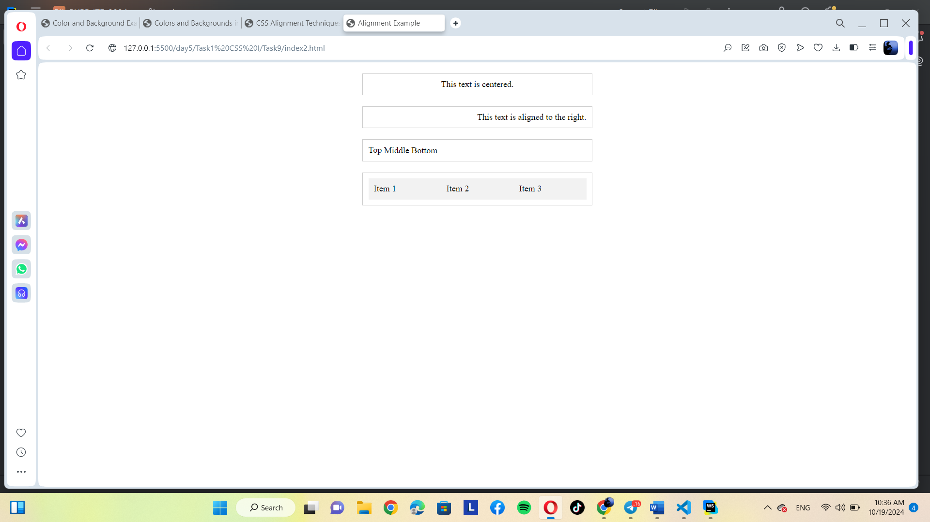

Both follow the prompt. Although Chat GPT is make color to make beautiful.